**Assignment 1 | 31st July 2021**

* 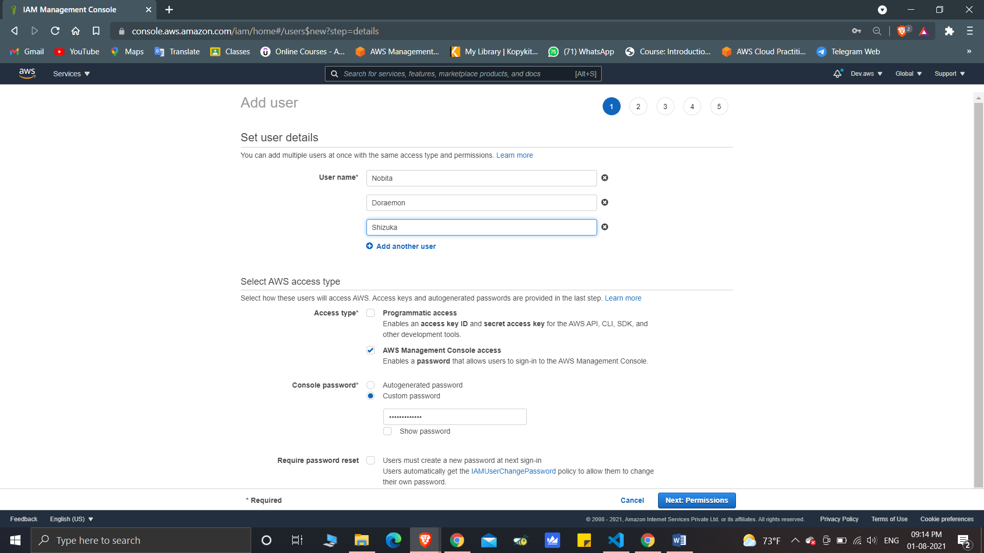Step1: Create 3 Users:-

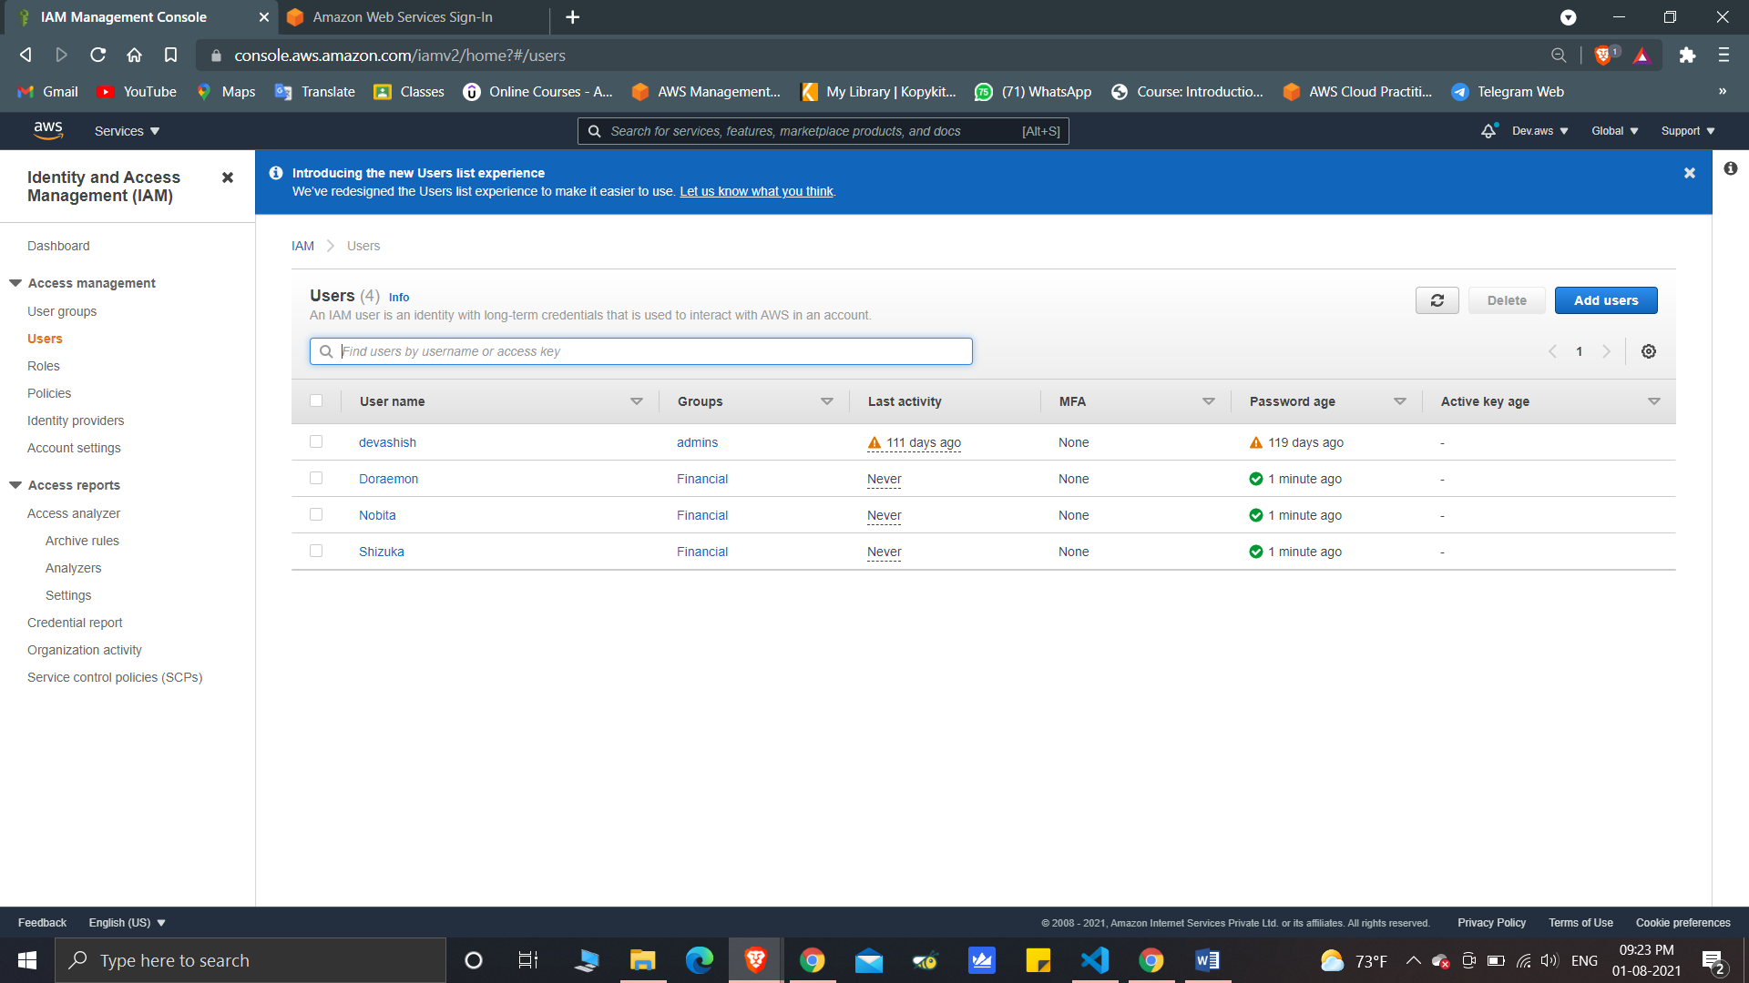

* Step2:Set user permissions:-

*Setting permission policy to user Doraemon-

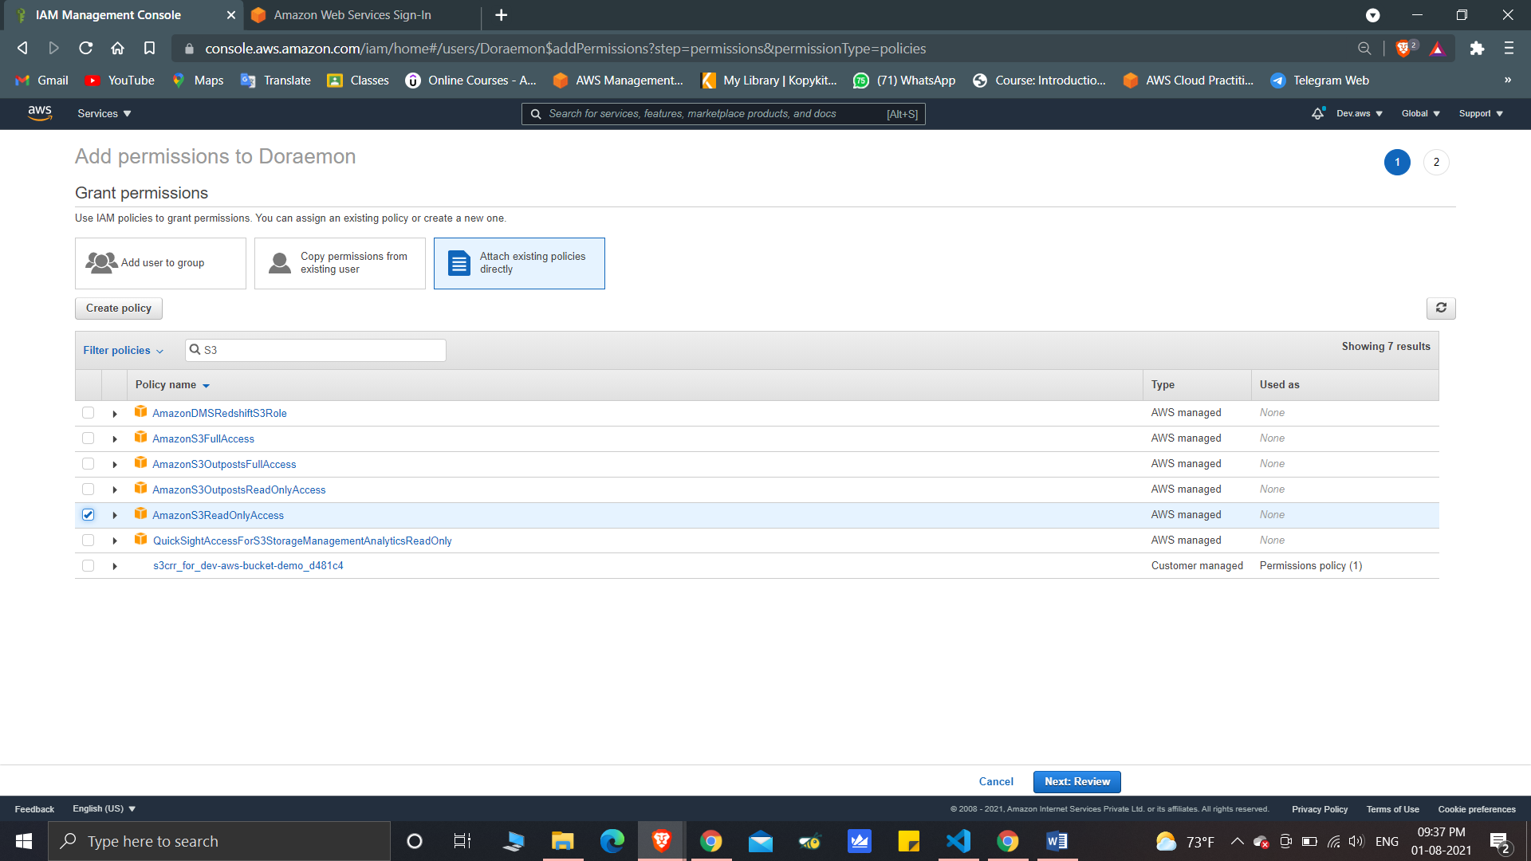

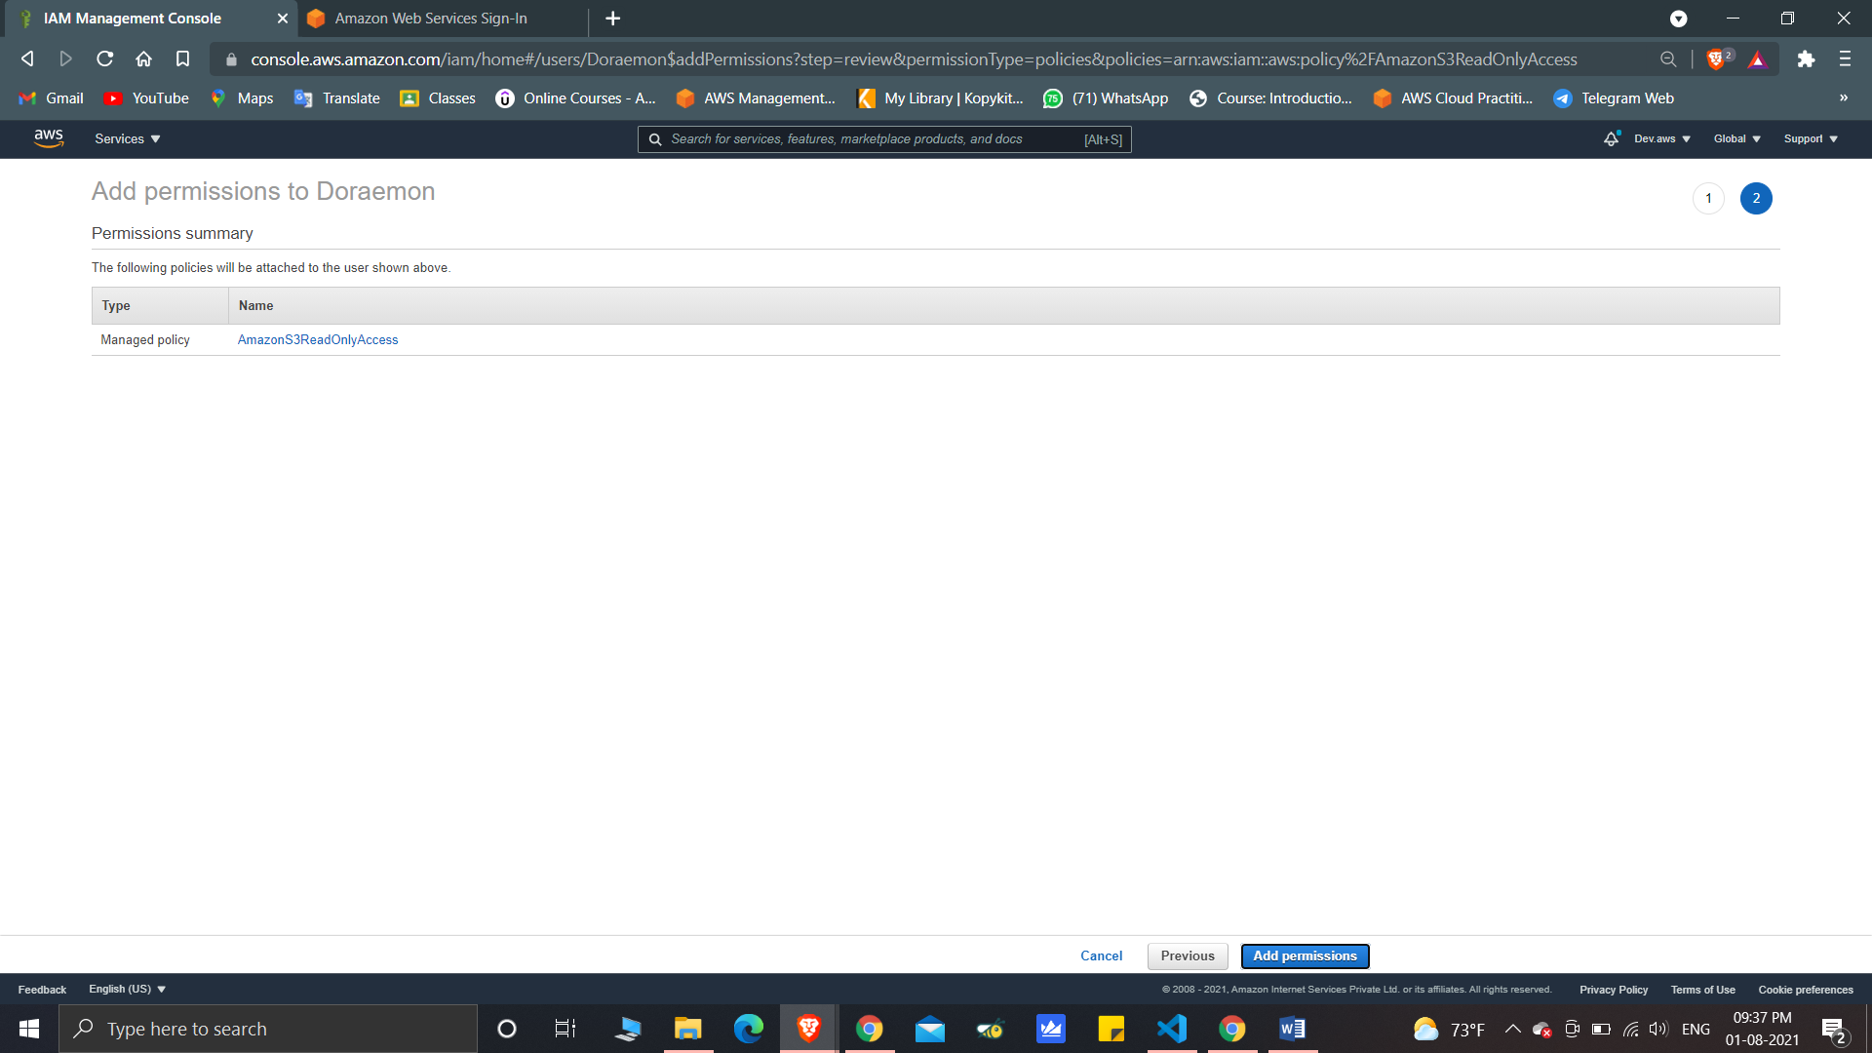

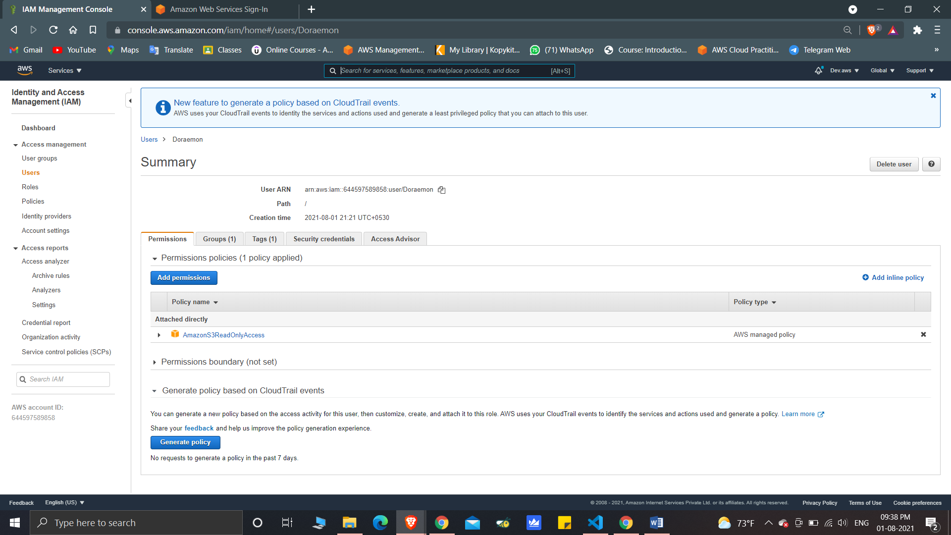

* Step3:

Create a Group

Set a unique group permission

Add users to group

(Created a group named “Finance” and added 3 users)

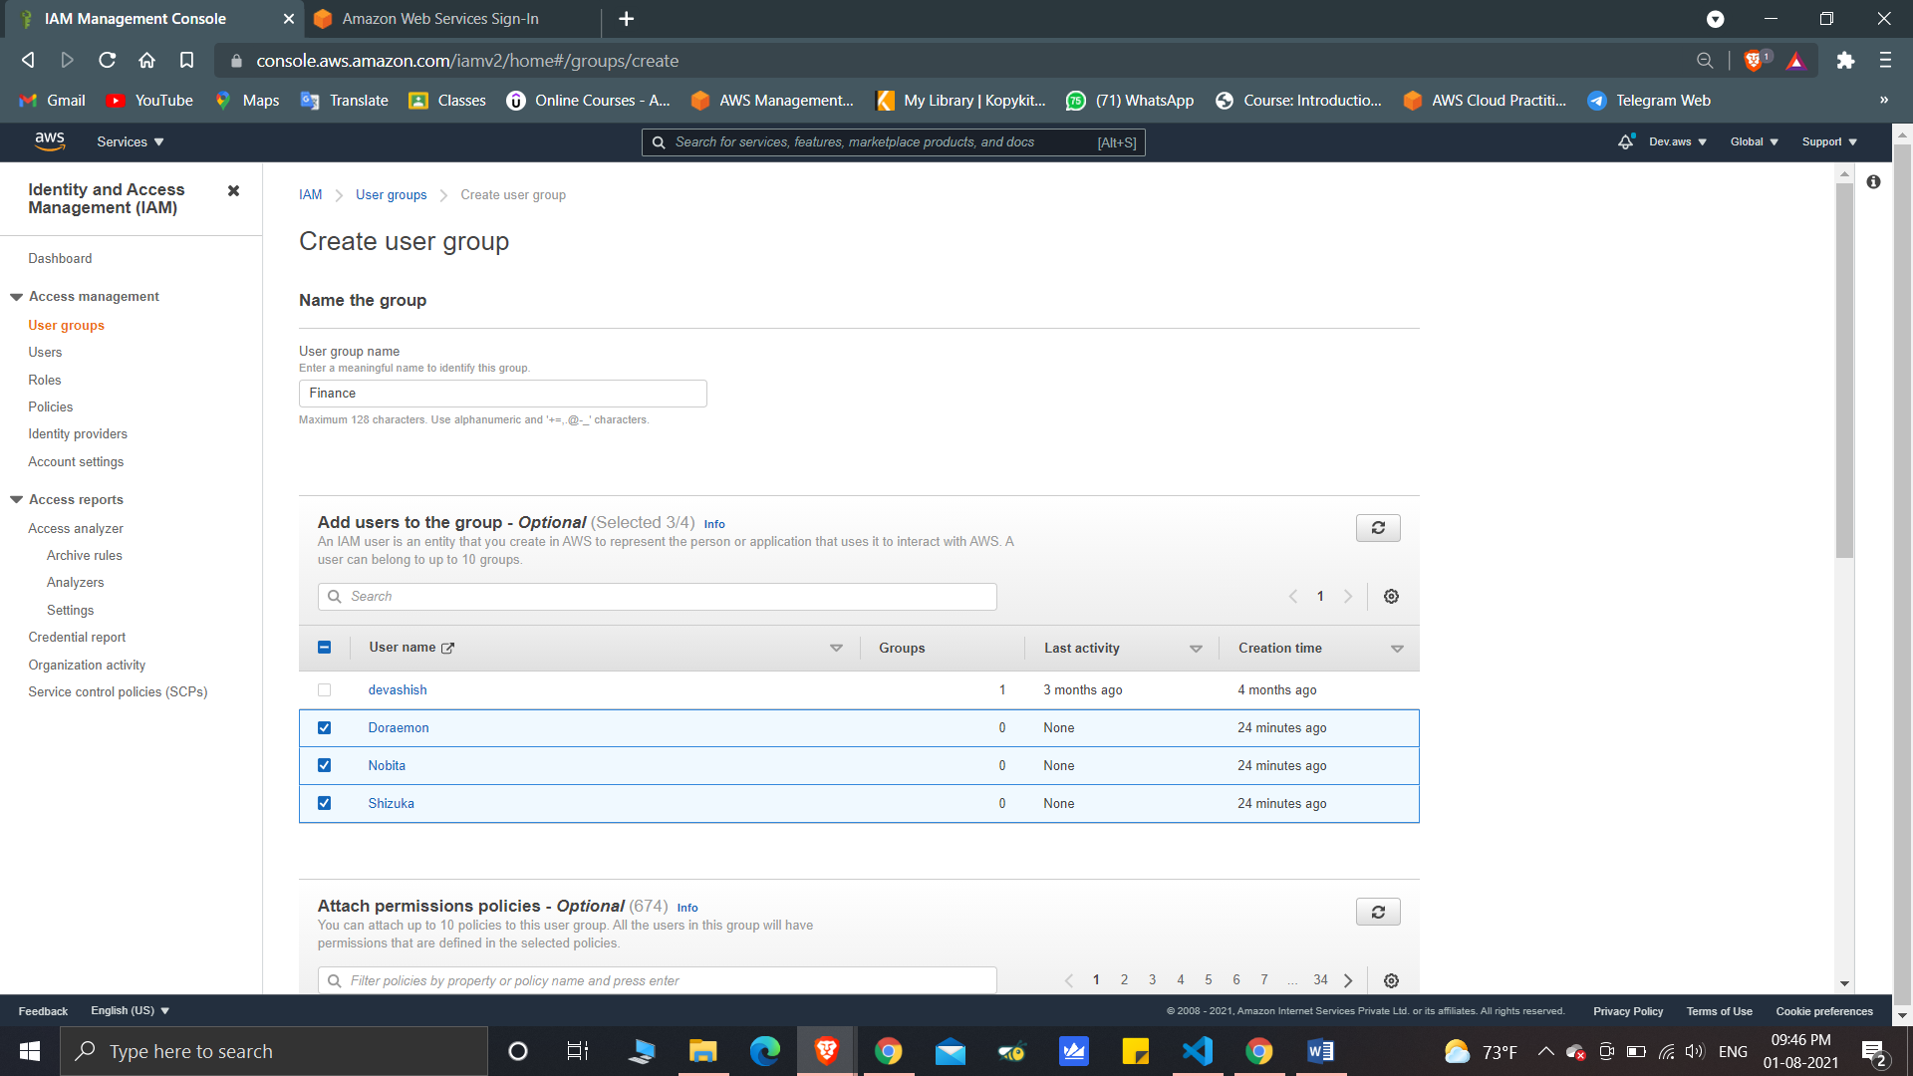

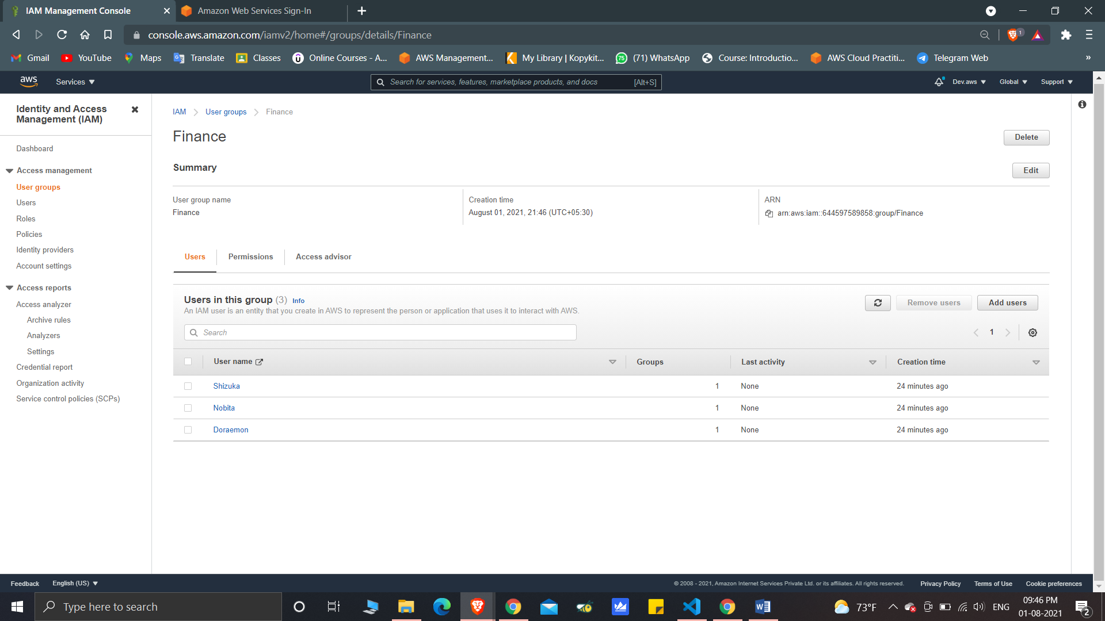

(Setting Permission policies to the Group)

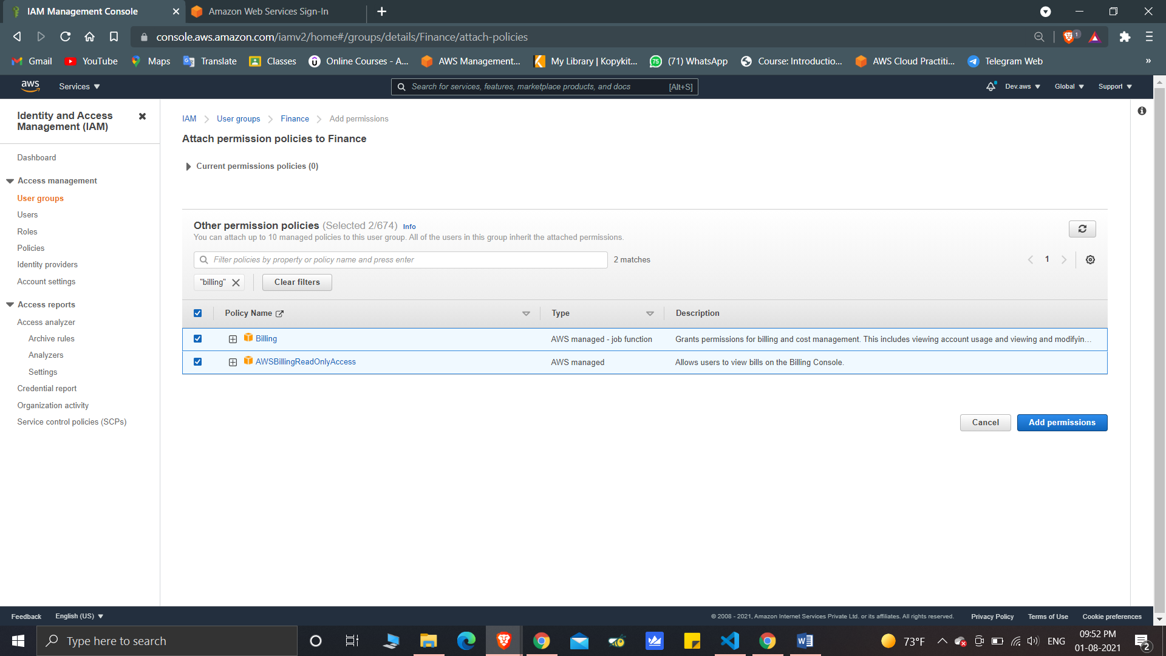

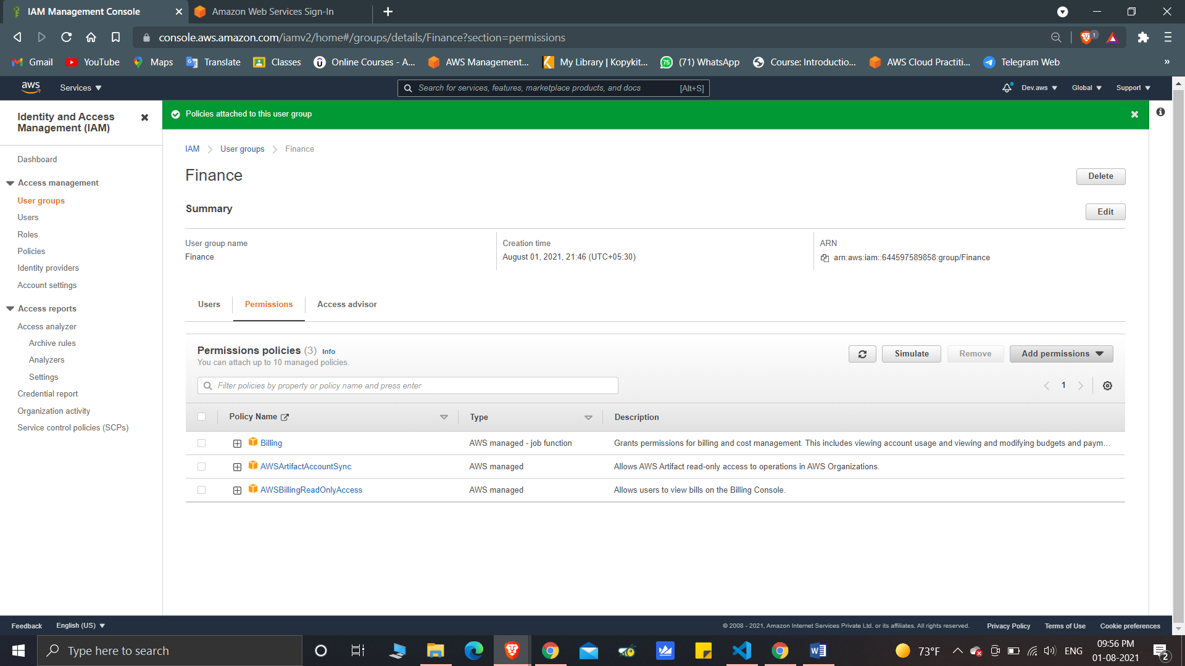

* Step4:

(Logging in IAM user)

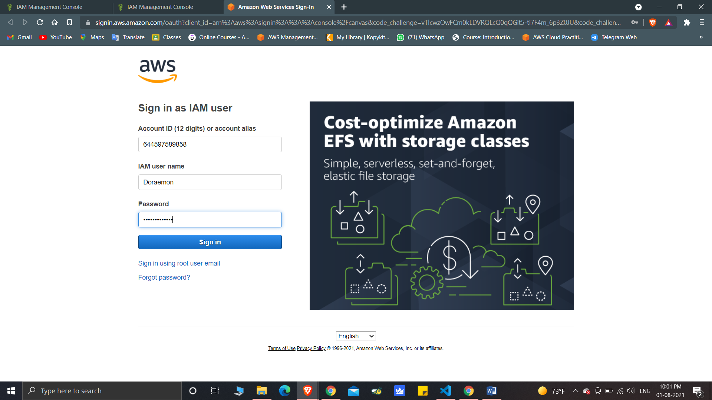

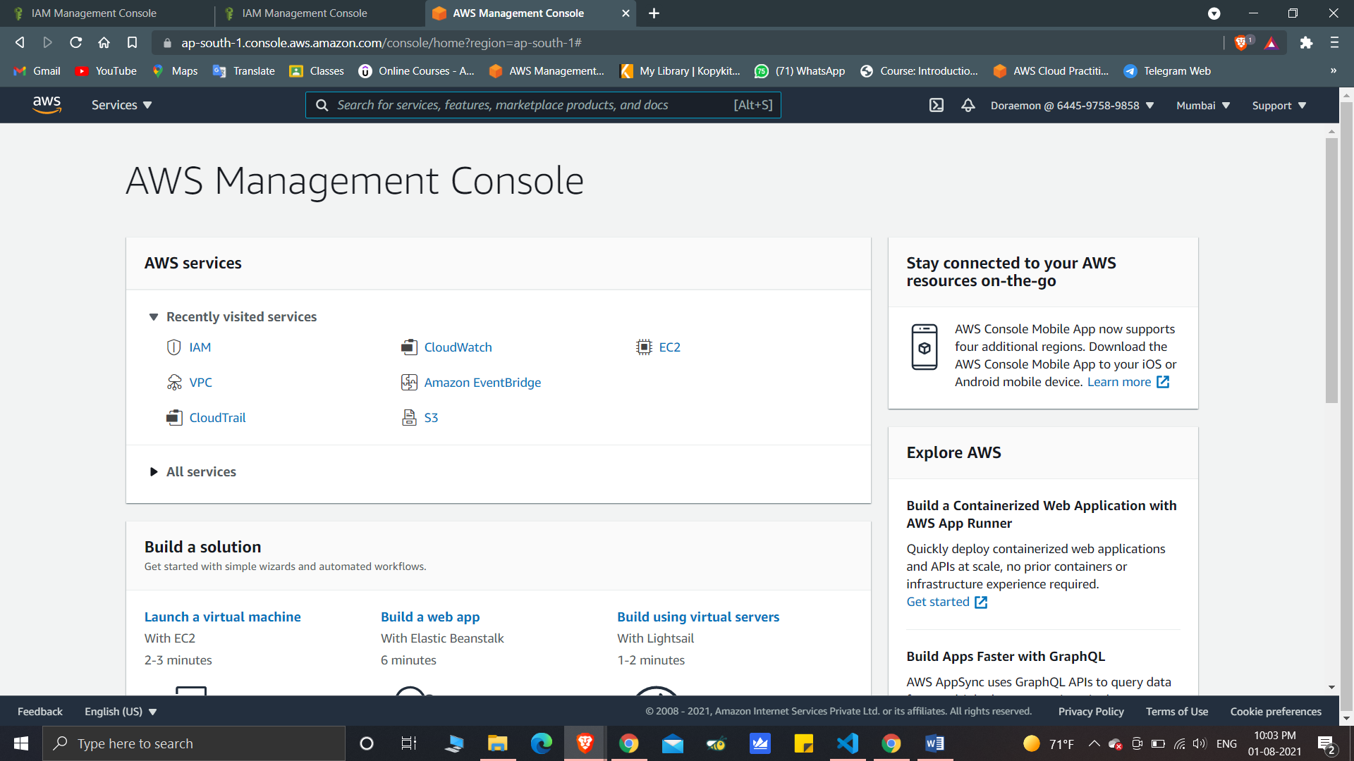

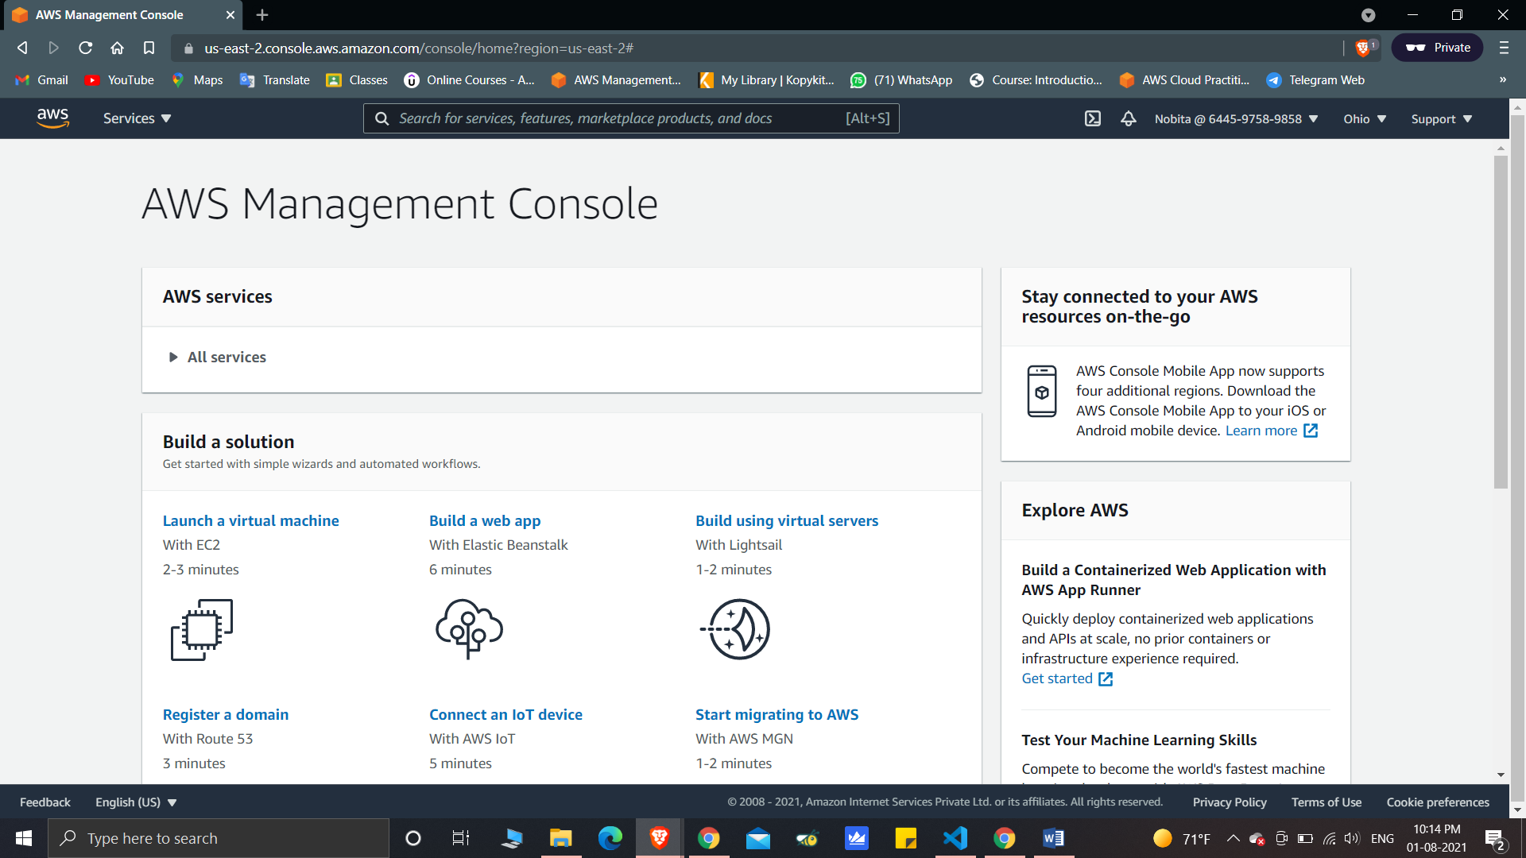

* Step5: Show that the user permission and the group permissions are applied:-

*(Group Permission to access Billing & cost Management Console)

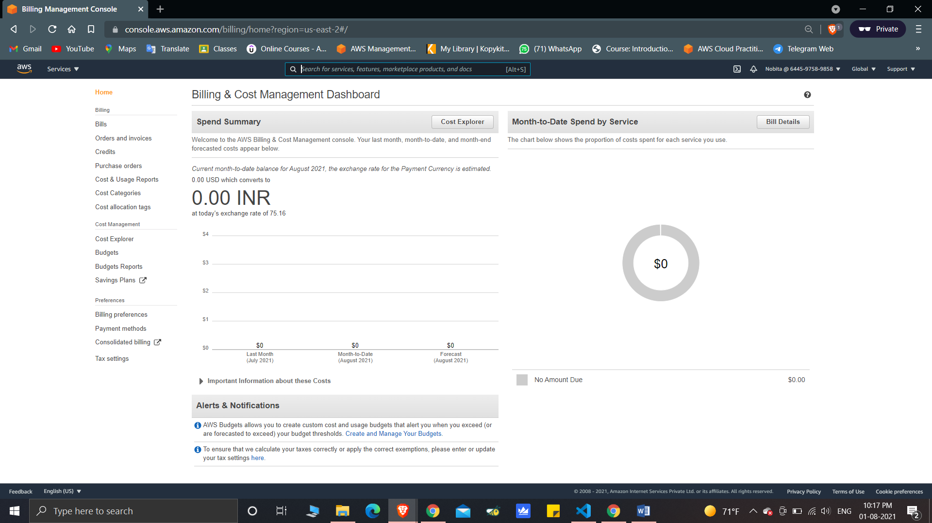

*(User Access to read S3 due to “AmazonS3ReadOnlyAcces” Policy)

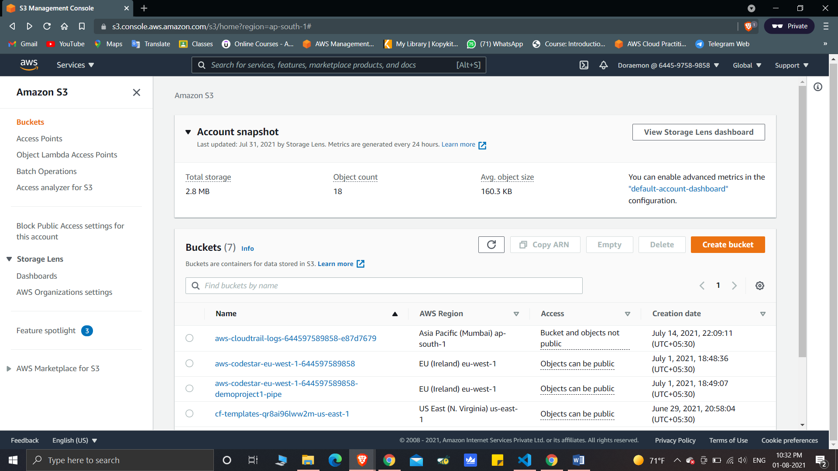

(*Permission to access IAM dashboard because of “IAMFullAcces” Policy)

